**TELECOM ARCHITECTURE**

**PROJECT REPORT**

**Shashank Bagda (92100133020)**

***Discrete Mathematics and Graph Theory***

***(01CT0310)***

**Sem – 3rd**

**Degree Engineering**

***in***

**Information and Communication Technology**



**Faculty of Technology**

**Marwadi University, Rajkot**

**SUMMARY**

Networking is the most essential and advanced version of Modern Communication Technology. We knowingly or unknowingly use the principles of Networking and Its Algorithms in our day-to-day life to get a better and optimized Network Solution. Many factors are working simultaneously to give the user a seamless interface. One of the Algorithms is Dijkstra’s Algorithm which is used to find the shortest path between the Source point and the Destination point. Now to do so, Concepts of Graph Theories are applied in the real life. Here in my project, I tried to demonstrate the whole working in Hardware + Software Based Model. Whole project is divided into two parts Hardware and Software so let’s see the coordination further.

**HARDWARE**



The very first step is to create a base layout of the network which we are generally using in our daily life. So, I designed the whole layout based on different types of networks which is divided into 4 different categories with respect to the area covered by that network.

1. (Top - Right) which represents the Home Network where no heavy traffic is concerned.
2. (Top – Left) which represents the Office Network which is somewhat concerned with multiple users and light traffic also.
3. (Bottom – Left) which represents the Local Area Network where so many users are also there and traffic is a prime concern.
4. (Bottom – Right) which represents the Baseband Network where the communication is in the Broadcast Manner, and also there are no any intermediate Node between Source and Destination.

Now the design is digitally ready but I wanted to Laser engrave it on a Hard Board. For that I used a software name SolidWorks which is specially used for laser printing and cutting works. Here are the images of the import file and simulation of the printing.

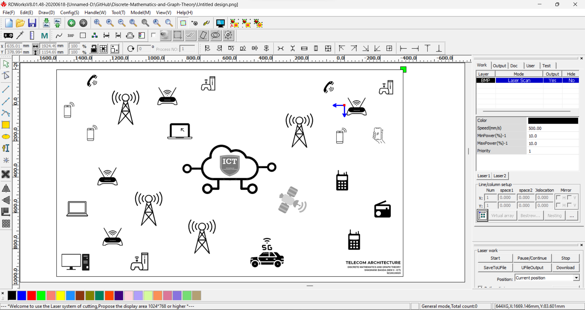

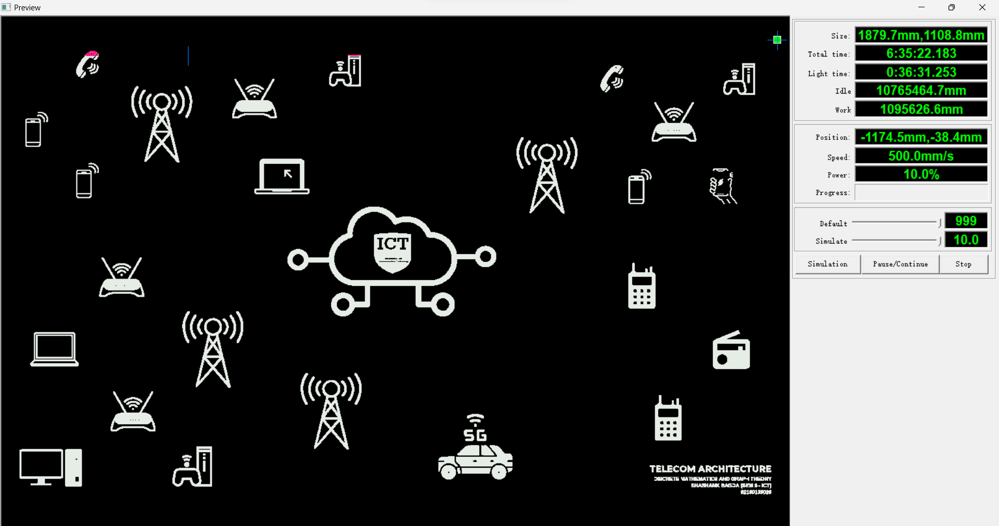

Now the base is ready and it’s time to built the Hardware Circuit Logic to take Input from switch then find the shortest path and then highlight it on Hardware with the help of Neo pixel Leds. The basic logic is, Switches are used for the input and defining the Source node and the Destination Node and according to the input the Development Board (Arduino Mega) will find the path. After the fixing of all the component the board will look as given below.

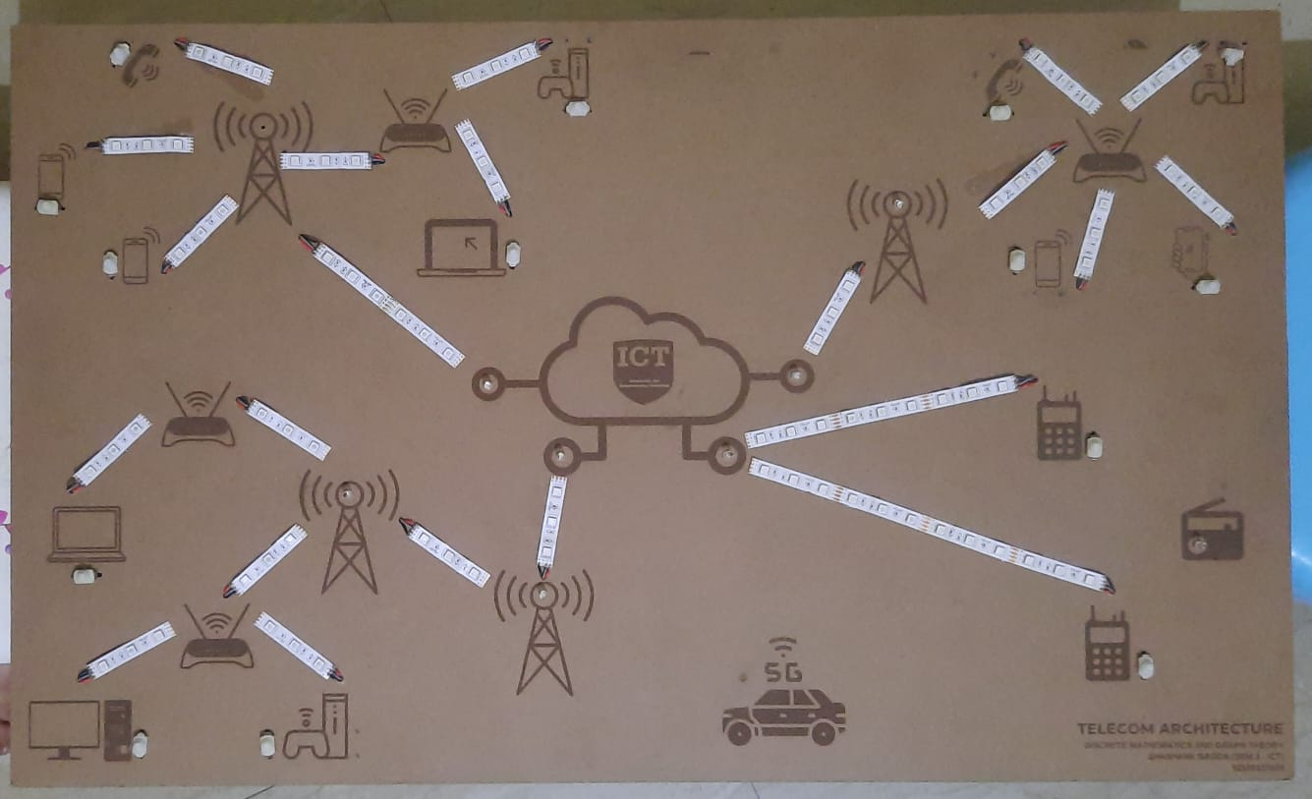

Now major part is wiring of all the components and accurate controlling of the edge and nodes. For the controlling of the edge, I used Transistor as a switch logic as shown in the image below and there is total 44 logics placed on the board i.e., 2 for each edge (1 for Uplink Color and 2 for Downlink Color). As an input from the switch, there are total 14 switching circuits for the user input. The following circuits are given below.

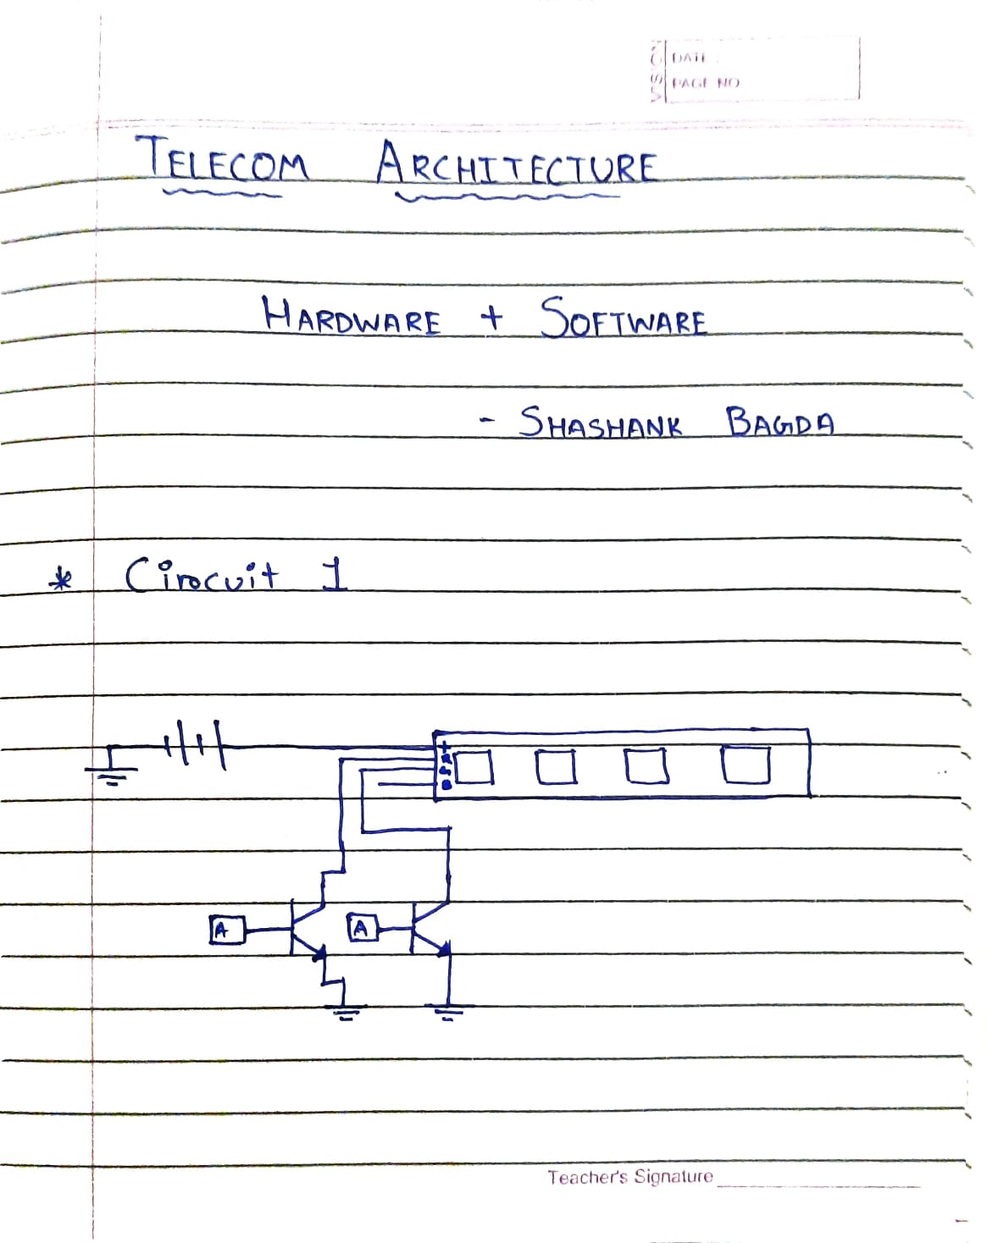

LED Controlling Circuit

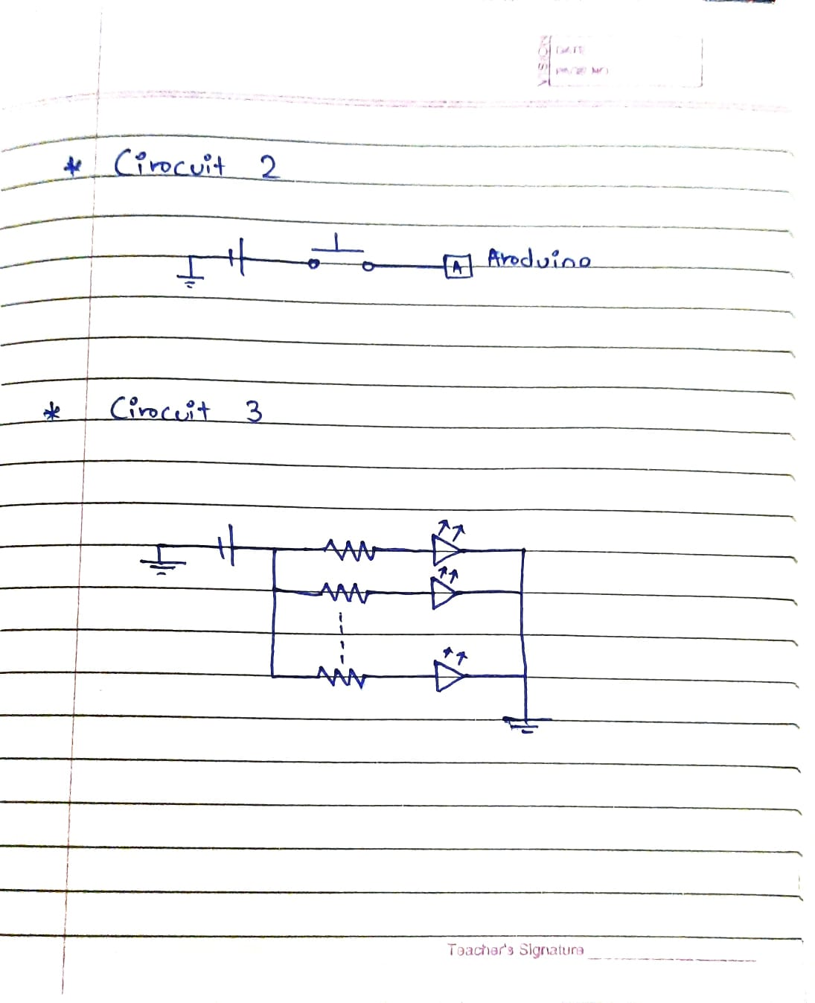

Input Switch Circuit



Critical Node Demonstration Circuit

After doing all this our Hardware is Ready!!

Now we will see the Software Part

**SOFTWARE**

Firstly I implemented the whole algorithm in C Language using the concept of Adjacency Matrix which is part of our syllabus. But my Hardware wasn’t working with laptop. My idea was something different so I have to convert the whole logic in the Arduino. I have to implement and verify 50 Different Conditions for the accurate implementation of Dijkstra’s Algorithm in Arduino. Now the code which was flashed on Arduino Mega board is a combination of Input from the Switch and the Controlling logic of the Edges.

You can find the code on my GitHub Repository:

<https://github.com/ShashankBagda/Discrete-Mathematics-and-Graph-Theory>

You can follow the link and find the whole progress of the project.

Now the Hardware and Software parts are ready and its time for the final output…

Representation of Network Link between two Gaming Consoles located at different areas

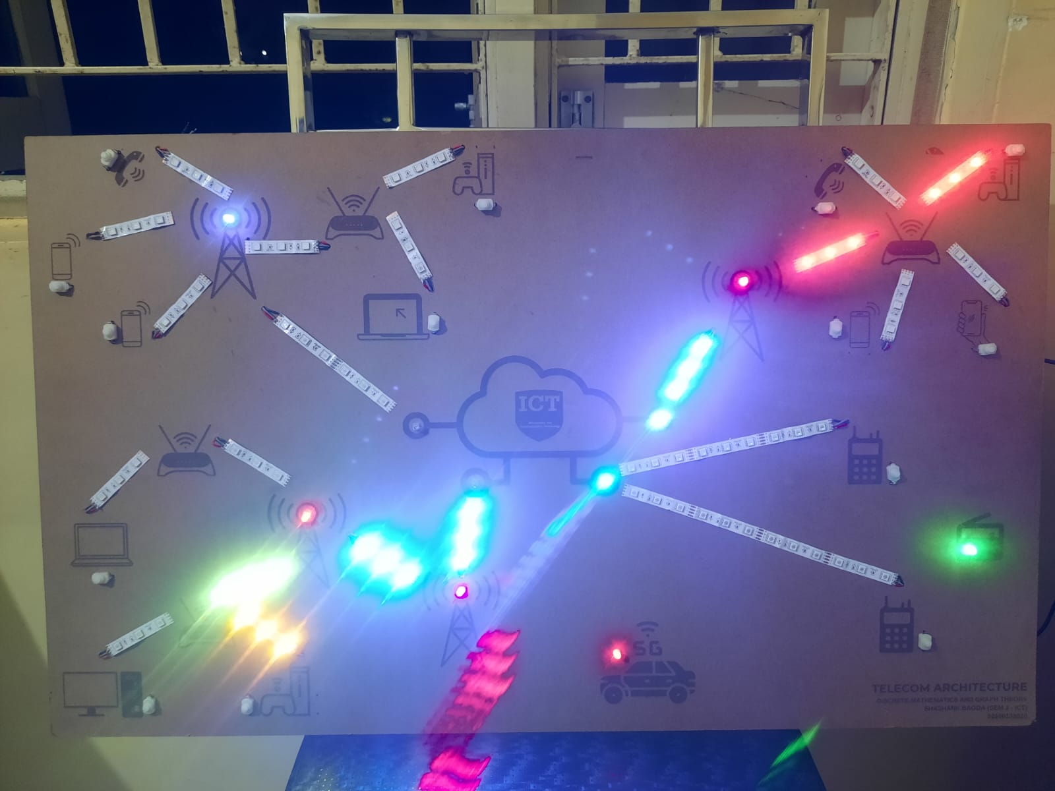

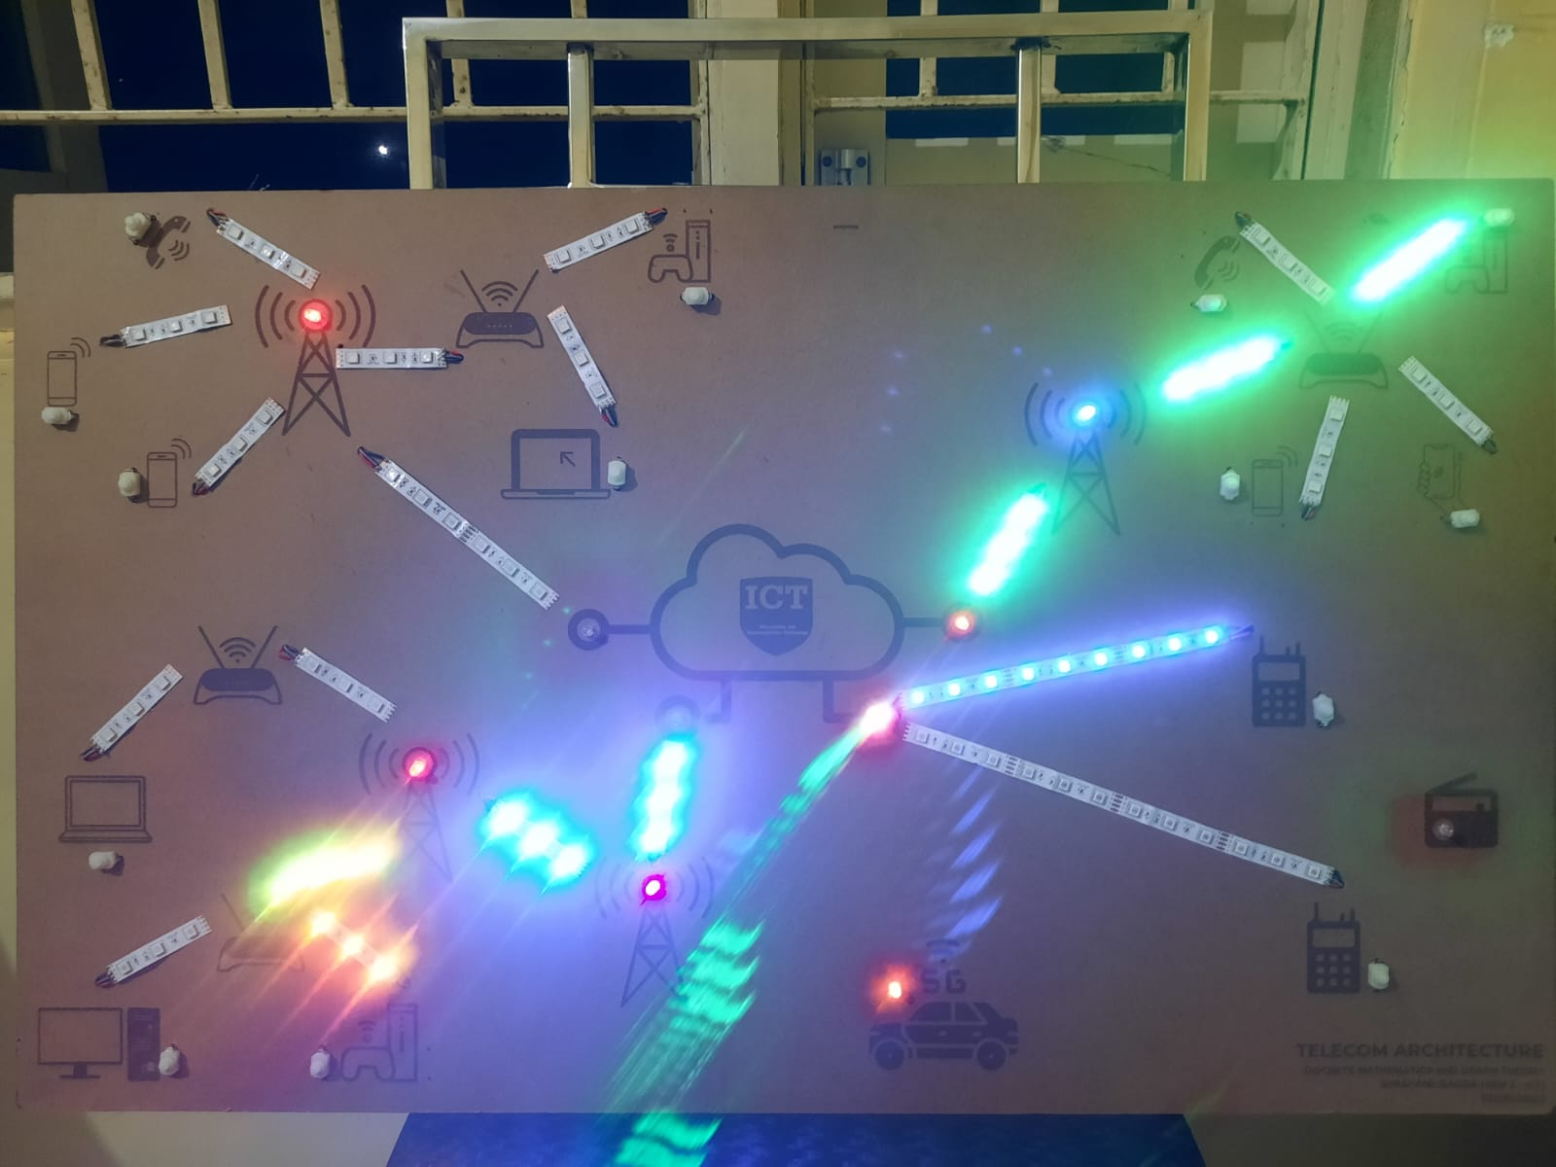

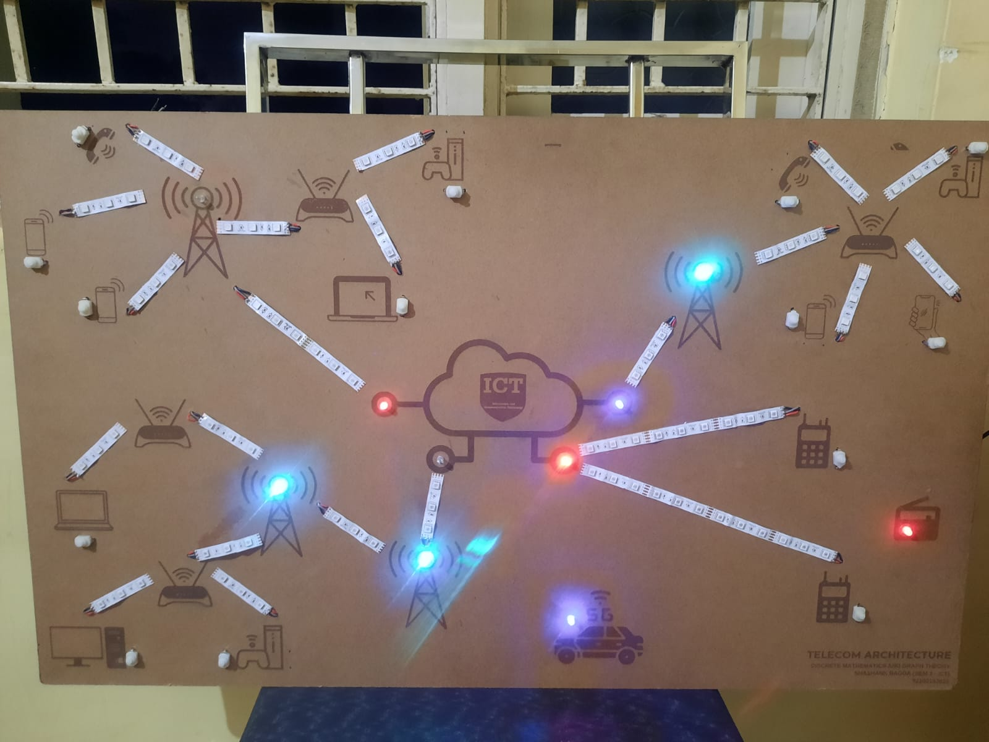

Critical Nodes of Network

THANK YOU